Latex Rubber Cells and Durability
By: John Lean, Ph.D.
Manager of Research and Development
Latex International

Shelton, Connecticut

Due to the unique process used to make Talalay Latex Rubber, Talalay Latex Rubber has a larger, more open cell structure than Dunlop latex Rubber for increased durability and air permeability. Talalay Latex Rubber is produced using the Talalay Process. A key step in the process is the vacuum expansion and freezing of the latex Rubber. The step results in a consistent, large, and open cell structure with superior properties compared to Dunlop latex Rubber.

Below are 40X magnified images of Dunlop latex Rubber and Talalay Latex Rubber with similar densities. The scale bars in the images are 250 μm or about 0.01 inches.
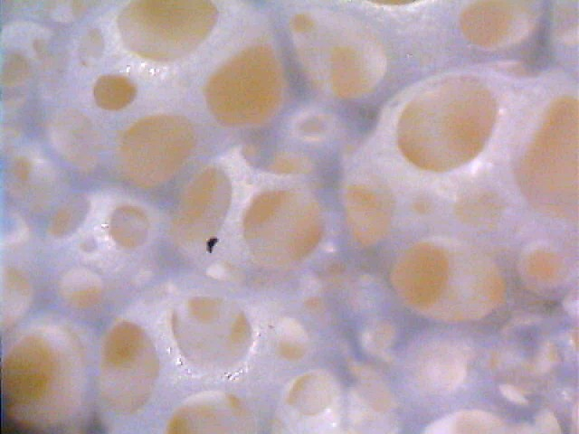
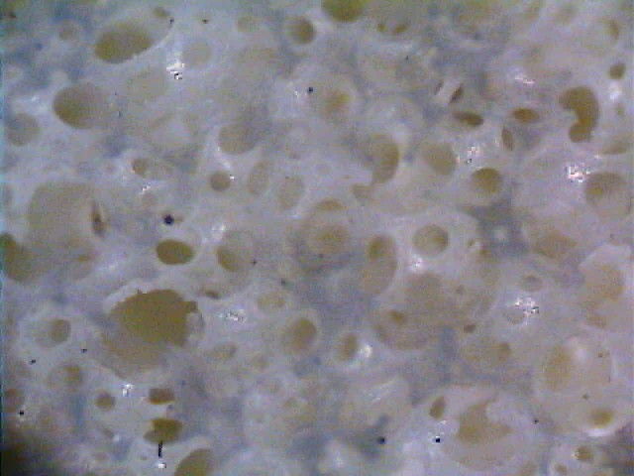
Dunlop Latex Rubber 40X Talalay Latex Rubber 40X
250 μm
250 μm

As the images show, the cell size of Talalay Latex Rubber is about twice as large as the cell size of Dunlop latex Rubber at the same density of material. The larger cell size means that there must be more material in the cell walls. The images clearly show that the cell walls are thicker in the Talalay Latex Rubber by about 20 μm on average.

As mentioned in a previous paper, the large cell structure of Talalay Latex Rubber is responsible for the unique compression profile and comfort of the material. The thicker, rubber cell walls are what give Talalay Latex Rubber its superior durability over other materials. The more material in the walls, the more resistance to breakage of the cells which ultimately leads to degradation of performance.

There are a number of methods to assess durability of latex Rubber materials including; Cornell Testing, Rollator Testing, Impact Testing, Roller Shear Testing, Elongation and Compression Set. All of the methods attempt to predict how a material will perform over the lifetime of the product. At Latex International we regularly perform an Impact Test. In the Impact Test a 17” x 17” x 6” block of latex Rubber is measured for ILD (indentation load deflection) and impacted with a 30 lbs foot for 25000 cycles over a 24 hour period. The latex Rubber is then allowed to recover for 24 hours and the ILD is measured again. The Impact Loss is the percentage difference between the original ILD and the impacted ILD. The test is meant to measure what kind of firmness change may be expected over a long period of time. Below are images of the Impact Tester.

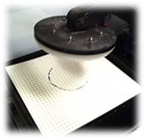
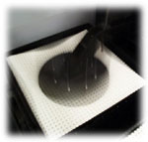
The cause of failure in the Impact Test is breakage of cell walls due to the impact. Impact Loss for Talalay Latex Rubber is on average 6% for all ILD’s. Impact Loss for a Dunlop latex Rubber is generally 16% or higher. The differences can be accounted for by the processes used to produce the latex Rubbers and quality of ingredients being used. Below are images of latex Rubber before and after impacting.

Another impact factor to latex Rubber durability is Rubber elongation. Elongation is a measure of how far a material will stretch before breaking. Elongation is reported as the percentage of length at breaking compared to the original length. A tensile testing machine is used to test elongation. Below is an image of the test apparatus and a piece of Rubber being tested.

Talalay Latex Rubber has much better elongation than Dunlop latex Rubber. The higher elongation means the latex Rubber can stretch farther and absorb more energy before breakage occurs. The property is not only important to durability but also to material handling. The source of Talalay Latex Rubber’s superior elongation lies in the thicker cell walls and quality starting materials.

The large, open cell structure of Talalay Latex Rubber has an important benefit to consumers, breathability. The cell structure is extremely open allowing air, moisture, and heat to freely move through the material. Below is a comparison of air permeability between Talalay Latex Rubber and a Dunlop latex Rubber. Testing was performed in accordance with ASTM D3574 procedures. The test apparatus is shown below.

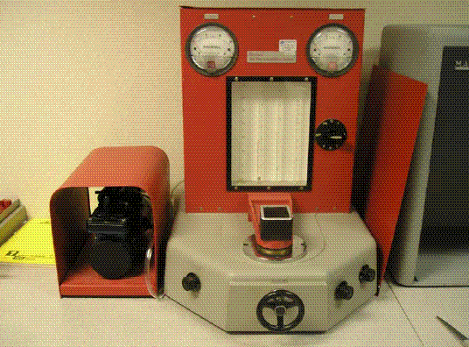
Air Permeability Test Apparatus

Air is drawn through a 2”x2”x1” block of Rubber until a specific pressure differential between the outside air pressure and a test chamber inside the apparatus is achieved. The more open the Rubber cell structure, the higher the air flow rate to achieve the pressure differential. Typical results for Dunlop latex Rubber and Talalay Latex Rubber with similar firmness ratings are given.

Dunlop Latex Rubber 1299 cm³/sec Talalay Latex Rubber 2652 cm³/sec

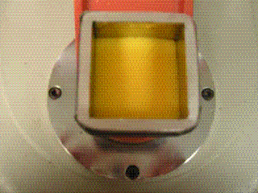
Talalay Latex Rubber is 100% more breathable than a standard Dunlop latex Rubber. Breathability is important for a comfortable sleeping environment. Air movement allows heat and moisture to be transferred away from the body keeping temperatures regulated.

